**A Soft Reminder for Respected Developers**

1**. From** **Test Scenarios Perspective**:

* Please check this spelling.

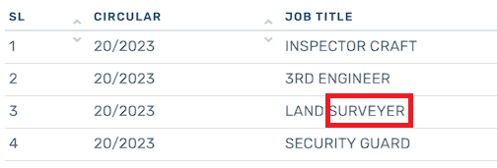

* Next & Previous Button is Not Working.



**NOTE:** This is just a soft reminder, please don't take it otherwise. Thank you